# CS 310 Changelog

Name: Matthew Rix

## Version 1.0.0 2023-03-29

Note: Jukebox Project

Major Changes:

* Added Ylvis.java to music.artists Graphical user interface, text, application

  Description automatically generated
* Added RayLaMontagne.java to music.artists Graphical user interface, text

  Description automatically generated

Minor Changes:

* Added in my name into the studentNames Array as StudentName3
* Created JUnit test for “Matthew Rix”, Ylvis tracks, and Ray LaMontagne tracks and ran them to success Graphical user interface, text, application, chat or text message

  Description automatically generated

Bug Fixes:

* Added Junit5 to build path
* Corrected spelling of studentNames in comment block on line 24

## Stashed a stash with @since 1.0

## Version 9.0.0 2023-03-20

Note: Tutorial Ten – Stashing changes in EGits

Major Changes:

* Stashed a stash with @since 1.0 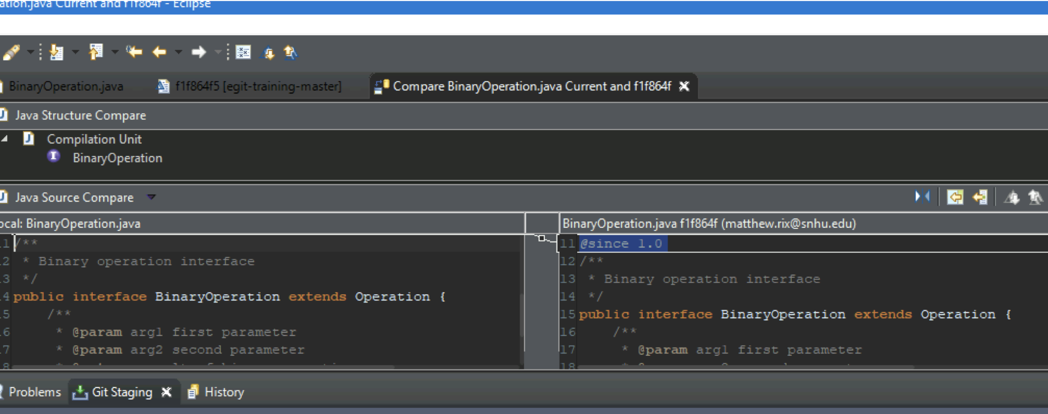
* Created new Javadoc branch from origin/master Graphical user interface, text, application, chat or text message

  Description automatically generated

Minor Changes:

* Applied stash changes to Javadoc branch Graphical user interface, text, application

  Description automatically generated

Bug Fixes:

N/A

## Version 8.0.0 2023-03-20

Note: Tutorial Nine – Use Git blame feature

Major Changes:

* Reviewed revisions in the Calculator.java file Graphical user interface, text, application

  Description automatically generated

Minor Changes:

* Reviewed revisions through history tab as well in the add-divide-functionality branch. Text

  Description automatically generated

Bug Fixes:

N/A

## Version 7.0.0 2023-03-20

Note: Tutorial Eight – Change a series of commits

Major Changes:

* Created add-modulo-functionality-corrected branch off add-multiply-functionality branch and added modulo class 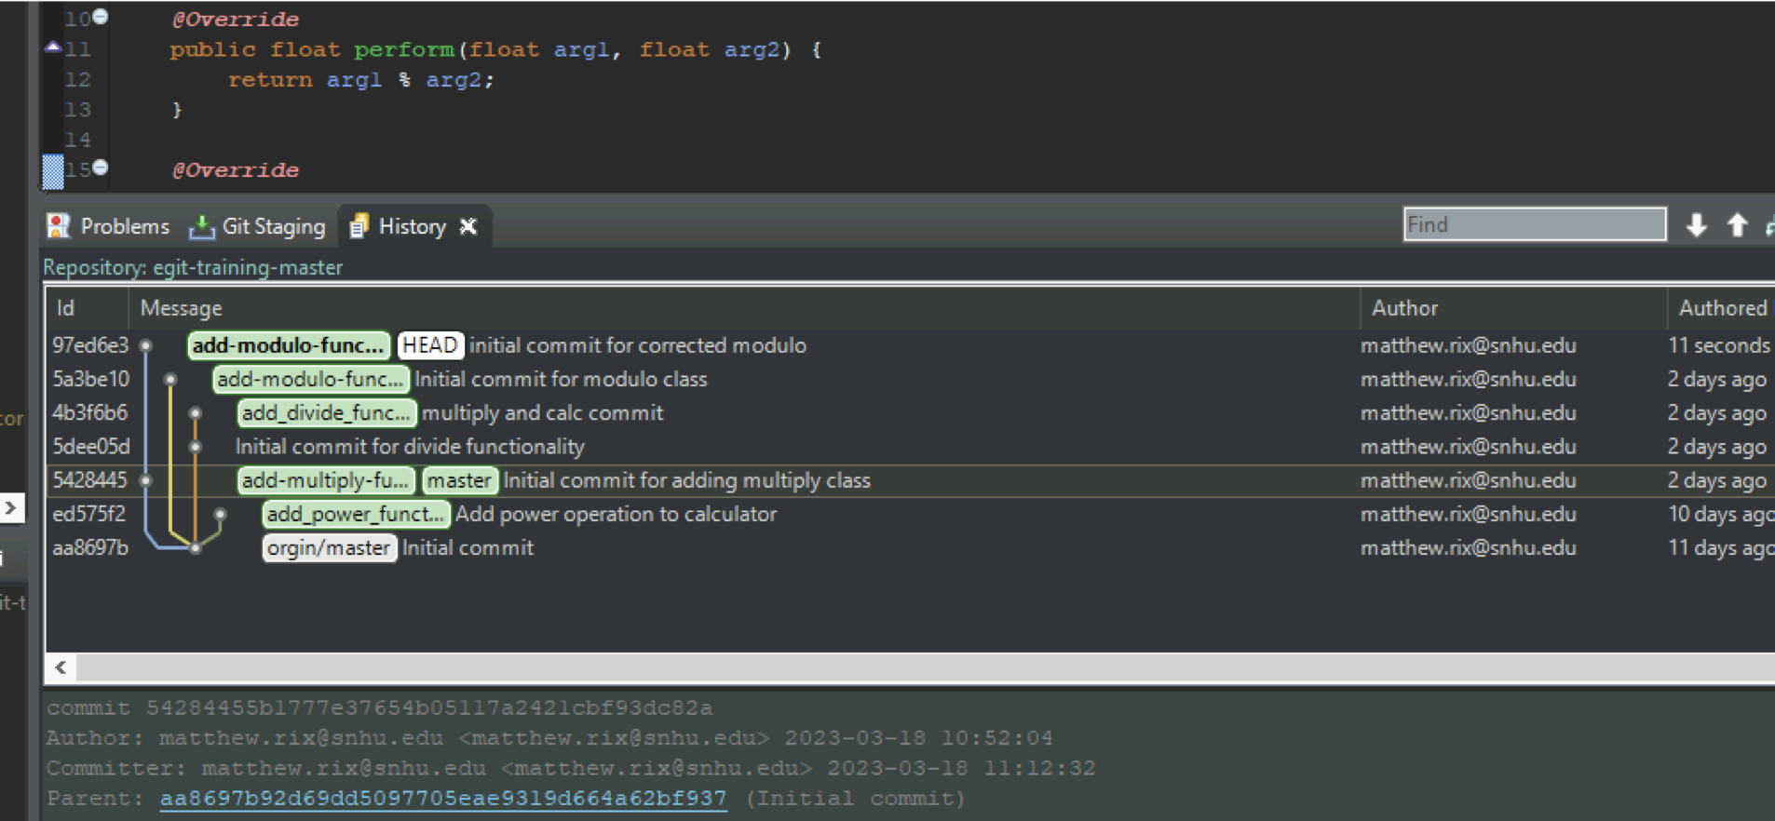

Minor Changes:

* Cherry picked previous add-modulo-functionality branch to new add-modulo-functionality-corrected branch.

Bug Fixes:

* N/A

## Version 6.0.0 2023-03-18

Note: Tutorial Seven – Reset branch to previous state

Major Changes:

* Created add-modulo-functionality branch off origin/master and added modulo class and functionality in separate commits 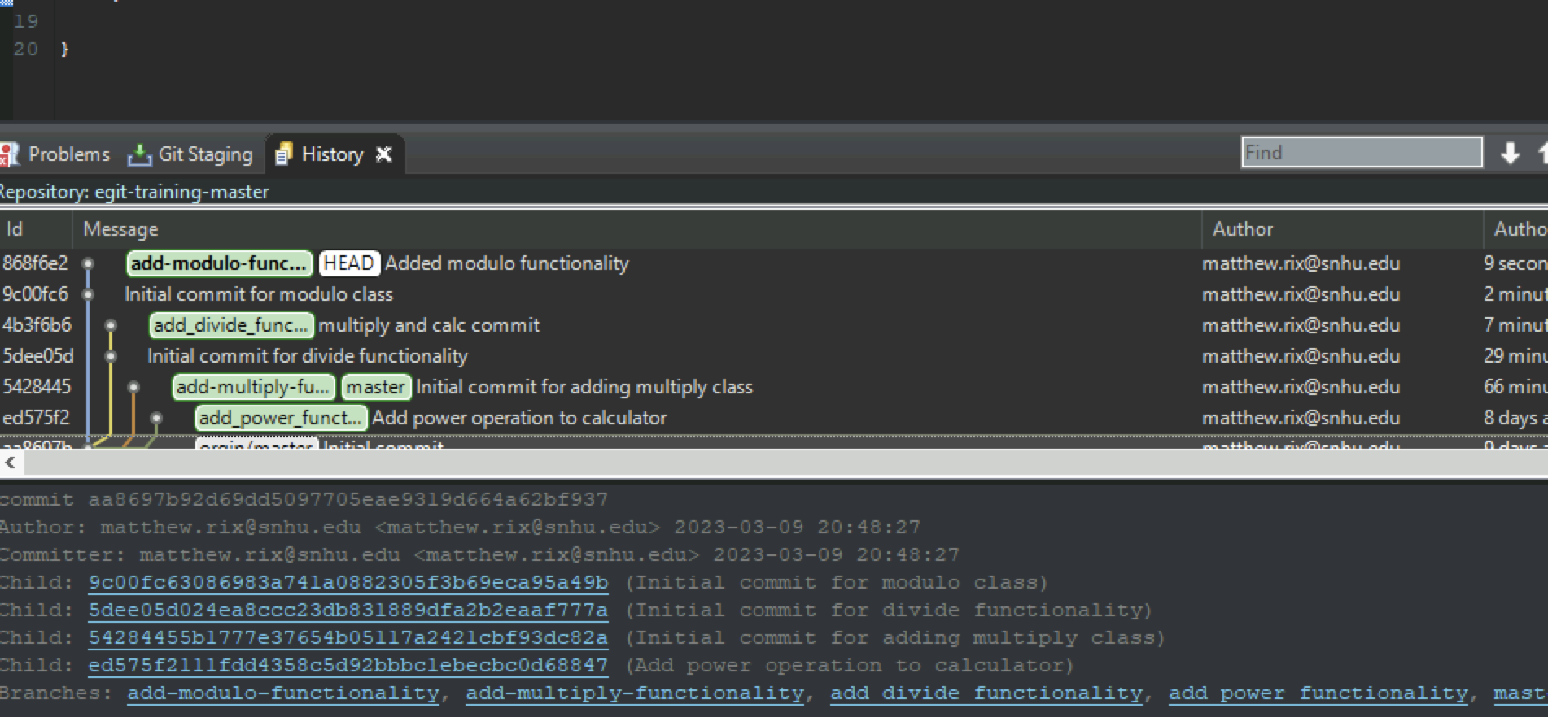

Minor Changes:

* Reset and amended the two separate initial modulo commits Graphical user interface, text, application

  Description automatically generated

Bug Fixes:

* N/A

## Version 5.0.0 2023-03-18

Note: Tutorial Six – Merge, Rebase, and Resolving Conflicts

Major Changes:

* Merged add-multiply-functionality branch with master Text

  Description automatically generated
* Merged add-divide-functionality but had conflicting code Graphical user interface, text, application

  Description automatically generated
* Resolved the conflicts 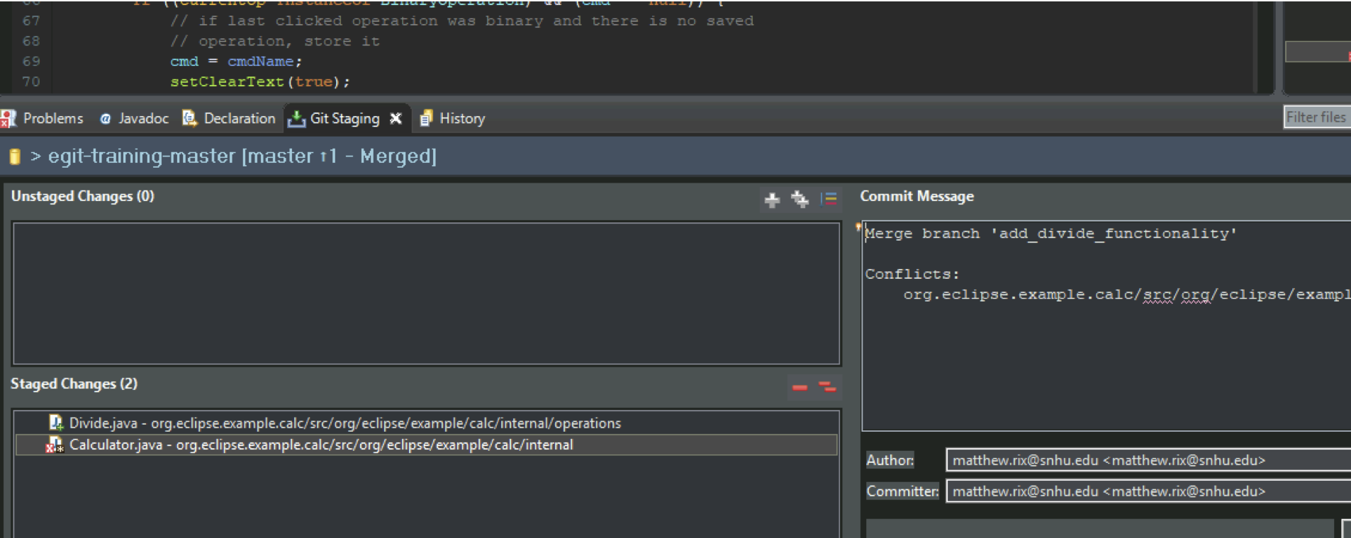

Minor Changes:

* Performed a hard reset add-divide-functionality 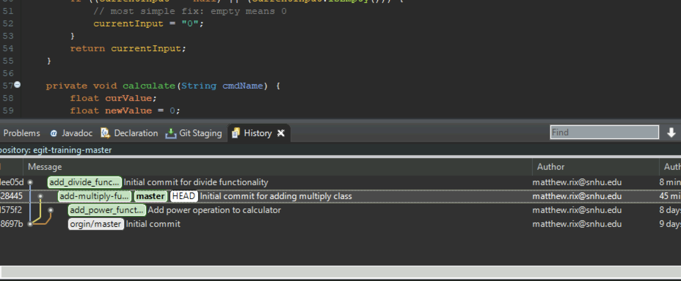
* Rebased add-divide-functionality with master A screenshot of a computer

  Description automatically generated with medium confidence
* Rverted rebase

Bug Fixes:

* N/A

NOTE: Tutorial Five – Fetch latest completed.

## Version 4.0.0 2023-03-18

Note: Tutorial Four – Work on branches in parallel

Major Changes:

* Added new branchGraphical user interface, application

  Description automatically generated
* Created new multiply Class Graphical user interface, text

  Description automatically generated

Minor Changes:

* Made a preliminary commit for the multiply class 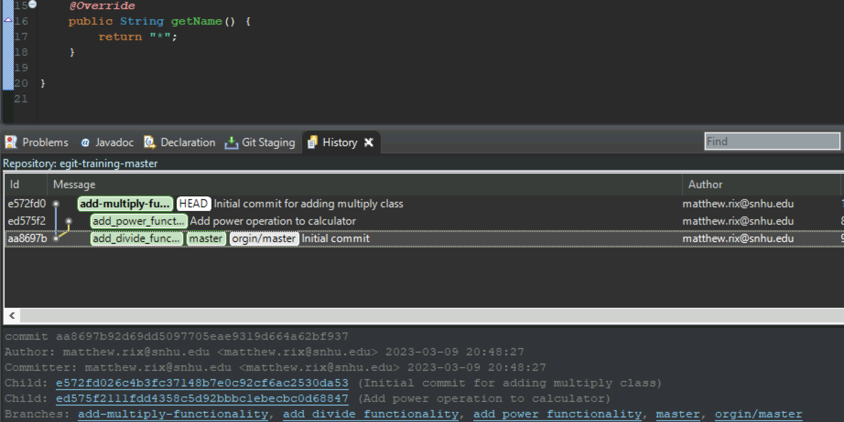
* Amended the multiply commit and pushed to bitbucket repo
* 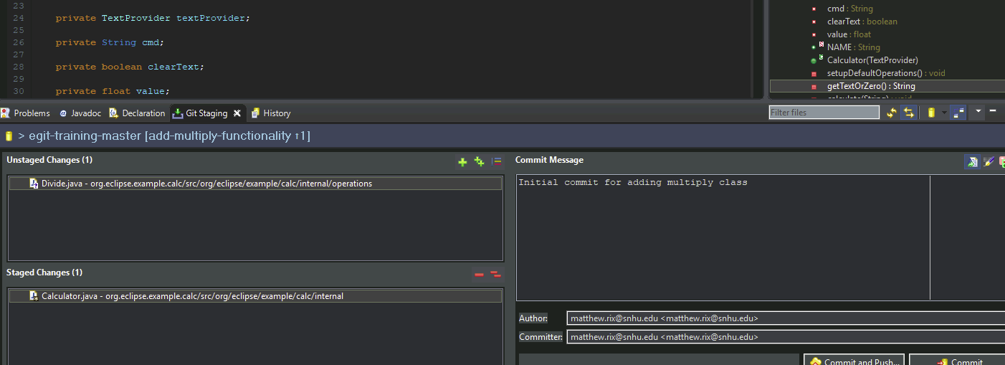

Bug Fixes:

* N/A

## Version 3.0.0 2023-03-09

Note: Tutorial Three – Inspecting the History

Major Changes:

* Configured change history.
  + Graphical user interface, text

    Description automatically generated
* Compared changes in Calculator.java.
  + Graphical user interface, text

    Description automatically generated

Minor Changes:

* Which commits have been done to package org.eclipse.example.calc.internal?
  + commits ed575f2 and aa8697b:
* Pick a commit ID and search for it. Which files have been touched in this commit? What were the changes?
  + ed575f2:
    - org.eclipse.example.calc/srcorg/eclipse/example/calc/internal/Calculator.java
      * Changed the imports and added Power function.
    - org.eclipse.example.calc/srcorg/eclipse/example/calc/internal/operations/Power.java
      * Added File (Initial commit)
* Which commits have changes toCalculator.java.
  + commits ed575f2 and aa8697b.

Bug Fixes:

* N/A

## Version 2.0.0 2023-03-09

Note: Tutorial Two – Develop Another Feature and Use Staging View

Major Changes:

* Created new branch in the Bitbucket repo:
  + Text

    Description automatically generated
* Developed the Power feature.
  + Text

    Description automatically generated

Minor Changes:

* Updated code in Calculator.java to include power method.
* Created uncommitted TODO comment in CalculatorUI.java.
* Committed Power functionality branch.
* Switched to Dark theme in Eclipse.
* Removed TOD comment with HEAD function.

Bug Fixes:

* N/A

## Version 1.0.0 2023-03-09

Note: Tutorial One – Develop a Feature Bug Fix

Major Changes:

* Created new local branch.

* Developed divide feature.

* UI updated with new operator.
* Graphical user interface, application, table

  Description automatically generated

Minor Changes:

* Updated calc code to insert divide method.
* Committed changes to local repo.

Bug Fixes:

* N/A